Coreen John - 33455847

project proposal

**Table of Contents**

1. Abstract 3

2. Introduction 3

2.1. Ageing population 6

2.2. Proposal 7

2.3. Existing systems 7

2.3.1. Omate Wherecome S3 7

2.3.2. The Tempo 7

2.3.3. Revolutionary Tracker 8

2.4. System functionality 8

3. Background 8

3.1. Paper 1: - Discharge Planning from hospital to home 8

3.2. Paper 2: What happens when people leave hospital and other care settings? Findings from the Healthwatch Network. 9

3.3. Paper 3: Loneliness: epidemic in modern society 10

3.4. Paper 4: Going Home Alone. Counting the cost to older people and the NHS 10

3.5. Paper 5: Impact of Hospital Discharge Planning on Meeting Patient Needs after Returning Home 11

3.6. Paper 6: National Survey of Hospital Patients 11

4. Overview Diagram 13

5. Project Plan Gantt Chart 14

6. Bibliography 17

**List of Figures**

Figure 1: 1997 - 2037 - Visualisation of percentage of population age 65 and over 4

Figure 2: Morality rates 1965-2020 5

Figure 3: Percentage of people expected to survive to age 100: 1981-2066 5

Figure 4: Overview diagram 12

# Abstract

The aim of the proposal is to address the lack of assistance patients receive when they are discharged from hospital. Currently there are some support mechanisms that are in place but because of financial restraints on social services, this assistance is limited or not offered. By creating a community of users through an electronic device, will give patients the capability of carrying out day to day activities post-discharge. The system will provide the user with a wearable device uses speech to transmit a message via SMS to a nominated person that has a compatible application. The device will also have the capability of sending SOS messages in the event of an emergency.

# Introduction

We currently have the largest UK population recorded, estimated at 66 million in 2017. This growth trend is set to continue with the population predicted to reach almost 73 million by 2041. As the population grows, and life expectancy rates improve we will also be living in an ageing population. In mid-2017 those aged 65 or more stood at 18.2% of the population, this will grow by 2.5% by 2027. See Figure 1 below (ONS, 2017)

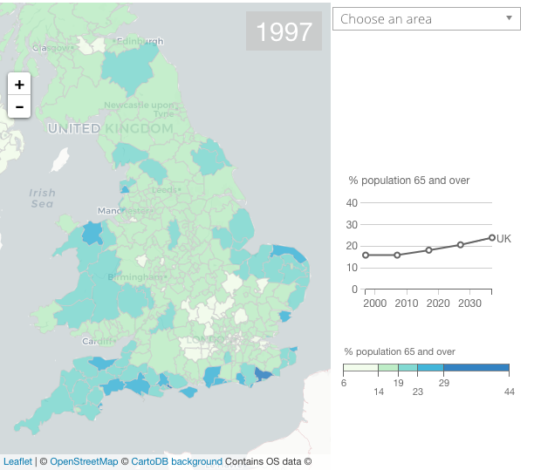

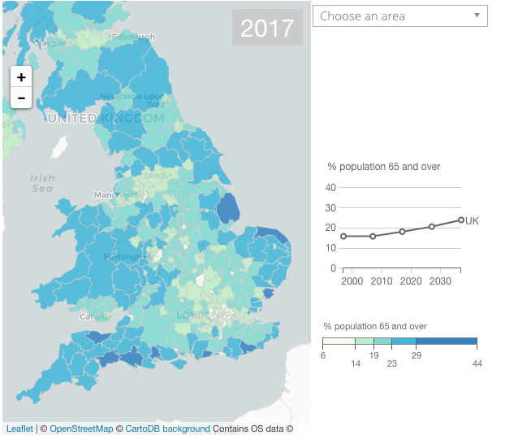

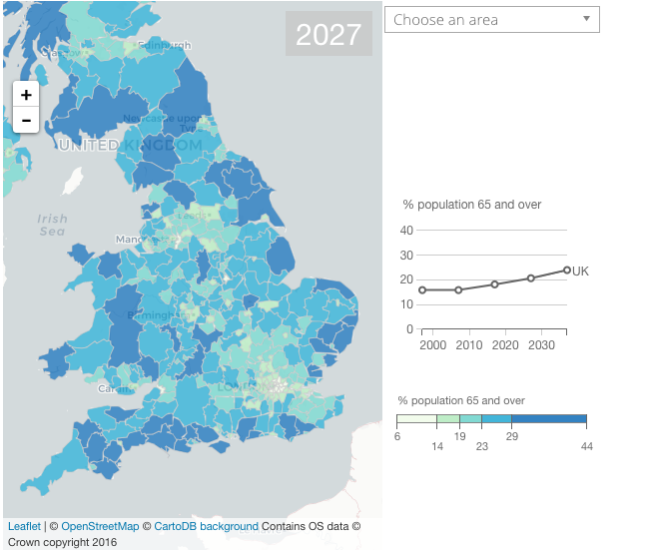

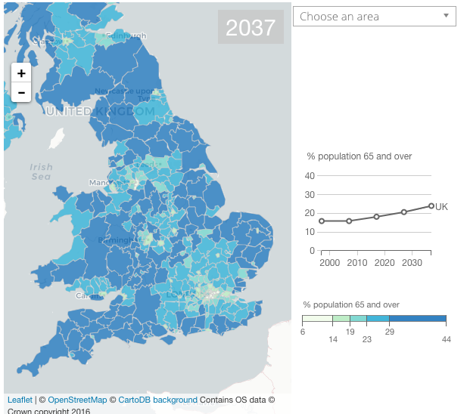

Figure : 1997 - 2037 - Visualisation of percentage of population age 65 and over

## Ageing population

As discussed above we are heading towards living in an ageing population with mortality rates at an all-time low. With this trend set to keep on a downward decline (see Figure 2 below). It said that 41% of males and 49% of females are set to survive to age 100 by 2066 (see Figure 3 below ). This is good news that the population is surviving for longer, it is indicative of healthier lifestyles and improved healthcare. There are many positive aspects to these findings; more volunteers, population of people working longer and people able to care for older family members. In contrast to this there are also many implications that need to be taken into consideration with an ageing population, ranging from: economic, public and social impact. As a person becomes older their health will degenerate with it, this will at some point impact and strain public health services. If people are living longer and working longer as a result they may not be able to care for ailing relatives, resulting in extra pressure on social services.

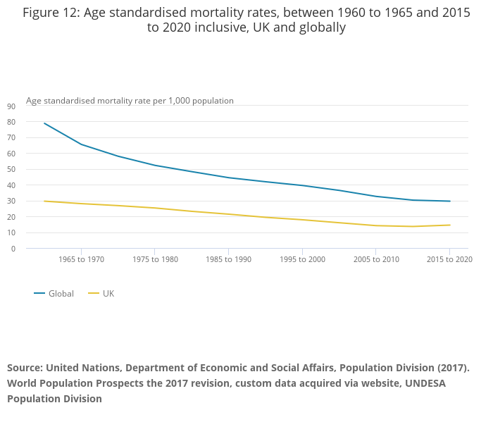

Figure : Morality rates 1965-2020

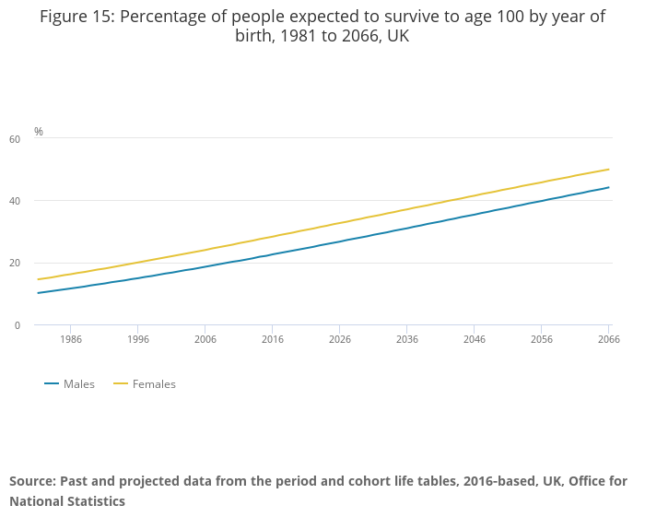

Figure : Percentage of people expected to survive to age 100: 1981-2066

An individual’s quality of life may be compromised as they get older. Older people are more likely to live alone, with many widowers who may not remarry after a death of a partner, normally if they do remarry it would be with an older person. Studies have shown that older people feel disconnected with ‘modern life’ and this could lead to isolation, with many local facilities closing such as banks, post offices etc. As the world is becoming more digitised this age group can be made to feel isolated as they more resistant to using technology. On the other hand, the study also reported that internet use for 75 year age group has doubled between 2011-2017. But it is fair to say that older people may never catch up with technological advance and because of this older people feel more connected with their community (ONS, 2017).

The consequences of an ageing society can be stated as:

* increase impact on social services as people live for longer;
* more resources will be needed for social services;
* increased isolation in older people;
* older people will find it more difficult to perform day to day activities;
* more hospital admissions.

## Proposal

With the population ageing and less support for patients who are discharged from hospital, an electronic device will be developed to offer help to those who require assistance with daily activities. The device will enable the user to request help by way of speech, for example “need bread and milk” or “need a letter posting”, “need to visit the bank”, SOS. The primary use: will be to assist people when they are discharged from hospital. An integrated application will be used with the device, so nominated members can receive the message and help. The devices can also send SOS to emergency services and is not limited to this particular group of people, it could also be used by people who are house bound, young carers etc.

## Existing systems

There are existing systems already on the market as follows:

## Omate Wherecome S3

A smart watch which has an integrated alarm system that reminds elderly people when to take their medication. The device also homes an SOS button which sends the location of the user via GPS to contacts over WI-FI or 3G. This system is different from the proposed device as it does not allow the user capability of speech.

## The Tempo

A wearable device that has a sensor that can help healthworkers identify serious health concerns in the elderly. Tempo learns the activity behaviour of the user. The device can also alert the carer if the user has eaten less that day. The data can be accessed with CarePredict software. This device is more of a health alert system and differs slightly from the proposed product, as it does not allow for message interchange with the user and the caregiver.

## Revolutionary Tracker

Silicone band, square metallic case with GPS and SOS button. With a press of a button the wearer can be connected to a family member or caregiver. Real-time tracking is achieved through tablet or smartphone with a compatible app. Users can set safe zones so if the user goes beyond the zone an alarm will be raised.

## System functionality

The user of the system may initially be issued with the device when discharged from hospital and this may form part of their discharge plan. They may need to meet certain criteria to be eligible for its use.

The system will primarily be used in the home. The system will offer users the reassurance that they will be able to gain assistance from a community of nominated caregivers, family, friends or neighbours. A wrist device or a device worn around the neck will be worn by the user. The user can use speech to communicate with the device. These words will be key words that are partnered with criteria i.e.:

“I need ***Bread*** “ = Key word. A message would then be sent via SMS and delivered to a nominated person who will have a compatible app. The nominated person would then be notified that the user needs bread. There will also be an emergency feature which will be activated if the user says an SOS keyword i.e.:

“I have ***fallen***” = Key word. A message would then be sent to the nominated person(s) so they can alert the authorities.

It will be a secure system, which will be light weight, discreet and easy to use. The device is inclusive and can be used by blind, deaf etc. The device will make use of GPS and speech technology enabling the user to utilise the device on a daily basis.

# Background

## Paper 1: - Discharge Planning from hospital to home

Barras SL., Cameron ID., Clemson LM., Lannin NA., McCluskey A., Shepperd S.   (2013) Discharge planning from hospital to home. *Cochrane Database of Systematic Reviews.* Issue 1. Art. No.: CD000313.DOI: 10.1002/14651858.CD000313.pub 4. [Online] <https://www.cochranelibrary.com/cdsr/doi/10.1002/14651858.CD000313.pub4/abstract> [Accessed: 30 October 2018]

In this paper Barras et al. discuss the implications of discharging planning.  The study was conducted in various countries such as US and UK were used in the case studies to ascertain how discharge procedures are conducted when a patient is admitted and released from hospital. A total of 11,964 participants were analysed in the study. There are discussions regarding discharge planning in hospitals. The study further discusses that some patients are discharged prematurely from hospital, resulting in unplanned readmission with a three-month period. It analysed that no sort of risk assessments is carried out before the patient is discharged. Therefore, no consideration is taken as to the patient’s social situation or if they have access to a support system on discharge. Barras et al, claim that those patients who had a care plan in place along with family input regarding their social situation, were less likely to be readmitted to hospital as their care needs were taken into consideration. Those patients whose social situation was not taken into consideration had a higher rate of readmission. Barras et al. did not conclude that discharge planning saves healthcare systems money.

This paper is relevant to the project as it highlights the psychological effects and social effects of patients on leaving hospital when there is not discharge plan in care. It highlights that if a patient has their social situation assessed it could prevent the rate of readmission to hospital, it also demonstrates that patients do need social support when leaving hospital to assist with day to day tasks.

## Paper 2: What happens when people leave hospital and other care settings? Findings from the Healthwatch Network.

Healthwatch (2017). What happens when people leave hospital and other care settings? Findings from the Healthwatch Network*.* [online] <https://www.healthwatch.co.uk/report/2017-10-05/what-happens-when-people-leave-hospital-and-other-care-settings> [Accessed: 30 October 2018]

Healthwatch is an independent body made up of people who monitor the use of health and social care services. A study conducted in 2015 analysed why discharges from hospital go wrong and the cost to the social health care system when this happens. 2,000 people have shared their experience of leaving care with Healthwatch. They conducted research on people who were in the process of leaving hospital with input from their relatives and carers. Their research concluded that 1,000 of people are kept longer in hospital than is medically necessary because of administration delays.  Coupled with the rising population of elderly healthcare costs going up along with poor patient experience. The key findings of their research found patients were not involved in decision-making of their discharge and were not given proper information. Patients also experienced delays and lack of coordination of with services such as medication and transport.  Many patients reported they were left without support after being discharged. A case study was analysed where a 75 year old patient was due to be discharged from hospital. The patient was deaf, immobile and diabetic. It was discovered that the patient was discharged at the wrong time so there were no carers to receive her, she was dumped on a bed (the transporting staff accessed her key from a keysafe).  A family member was unable to assist the patient immediately, so was left with no food and water for 2 hours. Therefore, this report has highlighted that 5,861 NHS beds a day occupied by unnecessary patients, this figure is up 23.4% compared with July 2015. There is clear evidence that hospitals are implementing unsafe discharges: patients are being transferred before its clinically safe. They also concluded that there is no clarity on ongoing support availability when patients are discharged from hospital.

This paper is relevant to the project as it clearly demonstrates that patients are being discharged before it has been ascertained whether they have sufficient support in place when they leave.  It also demonstrates that the availability of support when patients leave hospital is limited.

## Paper 3: Loneliness: epidemic in modern society

Killeen, C (1997). Loneliness: epidemic in modern society. *Journal of Advanced Nursing.* 28(4). Pp 762-770. [online] <https://m.recoveryonpurpose.com/upload/Loneliness%20An%20Epidemic%20in%20Modern%20Society.pdf>  [Accessed: 30 October 2018]

Kileen (1997) discusses the issue of loneliness in the modern society.  Loneliness can present itself in many forms and as a result has various implications such as low self-esteem, depression.  There are many forms of loneliness: alienation, social isolation, estrangement, aloneness and solitude. Kileen discusses that some of forms of loneliness cannot be solved as it is embodied and if a person tries to combat this on behalf of somebody else it could make them revert deeper into their state.  In contrast Kileen states that some patients that are admitted to hospital view this a respite from their loneliness. Kileen also states that elderly or adolescents are prone to loneliness more than any other type of group.

This paper has an indirect relevant to the project, the paper discusses the direct effects of loneliness and highlights that some patients who are lonely receive some sort of respite when they are admitted to hospital.  This is an important point to factor into the project as the proposed device will not only offer patients assistance when they are discharged from hospital but may also go some way to alleviate loneliness if the patient has a limited social network.  This may also prevent hospital readmissions if it is established on discharge if the patient has a social support network.

## Paper 4: Going Home Alone. Counting the cost to older people and the NHS

Royal Voluntary Service (2013) Going Home Alone. Counting the cost to older people and the NHS.  *RVS* [online] <https://www.royalvoluntaryservice.org.uk/Uploads/Documents/Reports%20and%20Reviews/Going_home_alone.pdf> [Accessed: 30 October 2018]

Royal Voluntary Service is a charity that offers voluntary services supporting the NHS hospitals and wider communities.  In their report ‘*Going Home Alone’* they reported there has been a 10% population increase in those over 75 years old, with an 38% increase in hospital discharges for those over 75 years old.  RVS reported 46% of those over 75 years old who had been in hospital within last five years were living alone and 20% of hospital admissions are avoidable. There will be 40% more 65 to 84-year olds by early 2030s and more than twice as many people aged 85 or more.  The report also highlights that there was very little support following discharge. With 15% of people said they felt anxious when leaving hospital, 41% felt they did not receive the support they needed and 30% of patients felt they needed just a little support were readmitted.  RVS also report ta lack of support at home is linked to readmission to hospital (with 51% of patients being readmitted after discharge). They also concluded that the level and duration of support that is offered is insufficient. RVS suggests that the duration of support should be extended beyond the first six weeks of discharge from hospital (with 62% of patients reporting that they still needed assistance getting to the shop more than 6 weeks following discharge).

This paper is relevant to the project as it clearly highlights the problem that is faced by patients who are discharged from hospital.  The report demonstrates a lack of support for patients that are discharged from hospital and duration of support is also limited. With the project that is being proposed this will offer patients on discharge from hospital the support they need to enable them to rehabilitate, eliminating the need of readmission.

## Paper 5: Impact of Hospital Discharge Planning on Meeting Patient Needs after Returning Home

Mamon, J., D.M., Fahey, M., Bone, LR., Oktay, J., Klein, L., (1992). Impact of Hospital Discharge Planning on Meeting Patient Needs after Returning Home. HSR: *Health Services Research* (27:2) <https://www.ncbi.nlm.nih.gov/pmc/articles/PMC1069871/pdf/hsresearch00065-0029.pdf> [Accessed 10 November 2018]

Bone et.al discuss the adequacy of discharge planning and how the different approaches to this can impact on patients. The report also highlights that discharge planning has many measurable benefits to patients. They demonstrate that some patients may be discharged with a higher level of dependency pre-admission and a patient’s social mobility should be assessed before admission to determine whether they would need support on discharge. It was found that discharge planning was more effective when the patient had a home care plan in place. Throughout the study 5 hospitals discharge plans were analysed. Follow up surveys were conducted with the hospital and patients. Patients were asked about their activities of daily living (“ADL”). These comprised of transport, housing, legal and financial needs. From the results of the survey 62% reported that they needed additional assistance and found that their Unmet needs resulted in readmission. 97% of patients needed some kind of aftercare and 11% had unmet activity limitation need. The report concluded that formal discharge planning has an effect in reducing unmet treatment needs and recommended that hospitals should be co-ordinating aftercare for patients for a longer duration of time.

This paper is relevant for the project proposed as it again highlights that patients being discharged from hospital do not have sufficient care plans in place to ascertain whether they have sufficient support when being discharged and if they are offered support the duration of that support is very limited. This clearly highlights a need for the proposed device.

## Paper 6: National Survey of Hospital Patients

Bruster, S., Jarman,B., Bosanquet, N., Weston, D, Erens, R,  Delbanco, TL., (1994) National Survey of Hospital Patients *BMJ 1994;309:1542* <https://www.bmj.com/content/309/6968/1542.short> [Accessed: 10 November 2018]

Bosanquet et.al conducted an in depth analysis patient care in hospitals.  The analysis was borne from the requirement to review the NHS as there was a requirement for hospitals to assess the quality of care received by patients.  The survey was designed to analyse 108 hospitals used in sample size and was conducted between 1992-1993. A random sample of 36 NHS hospitals with a sample group of 143 patients per hospital ranging from Medical and surgical wards.  They conducted a series of interviews at home or place 2-4 weeks after discharge via a questionnaire. They asked participants about a series of questions based on:

* pre-admission procedures;
* Admission;
* communication with staff;
* physical care;
* tests and operations;
* help from staff;
* pain management; and
* discharge planning.

The report highlighted that discharge planning was a principal problem that had been reported by participants. One of the most prominent problems highlighted was the lack of communication management.  Patients reported they were not given adequate information on how they should conduct their lives when they go home after discharge.

This paper is relevant to the project as it highlights that discharge planning was highlighted as one of the principal problem’s patients face when being discharged from hospital care.  Patients are left feeling that they are not given enough information on their aftercare. This helps strengthen the proposal as discharge planning could be incorporated as a feature on the project is being proposed.

# Overview Diagram

Figure 4: Overview diagram

# Project Plan Gantt Chart







# Bibliography

Barras SL., Cameron ID., Clemson LM., Lannin NA., McCluskey A., Shepperd S. (2013) Discharge planning from hospital to home. *Cochrane Database of Systematic Reviews.* Issue 1. Art. No.: CD000313.DOI: 10.1002/14651858.CD000313.pub 4. [Online] <https://www.cochranelibrary.com/cdsr/doi/10.1002/14651858.CD000313.pub4/abstract> [Accessed: 30 October 2018]

Healthwatch. (2017). What happens when people leave hospital and other care settings? Findings from the Healthwatch Network*.* [online] <https://www.healthwatch.co.uk/report/2017-10-05/what-happens-when-people-leave-hospital-and-other-care-settings> [Accessed: 30 October 2018]

Killeen, C (1997). Loneliness: epidemic in modern society. *Journal of Advanced Nursing.* 28(4). pp 762-770. [online] <https://m.recoveryonpurpose.com/upload/Loneliness%20An%20Epidemic%20in%20Modern%20Society.pdf>  [Accessed: 30 October 2018]

Office of National Statistics. (2017). Overview of the UK population: November 2018. An overview of the UK population, how it’s changed, what has caused it to change and how it is projected to change in the future. The UK population is also compared with other European countries. <https://www.ons.gov.uk/peoplepopulationandcommunity/populationandmigration/populationestimates/articles/overviewoftheukpopulation/november2018> [Accessed 11 November 2018]

Office of National Statistics (2018). Living longer - how our population is changing and why it matters. Overview of population ageing in the UK and some of the implications for the economy, public services, society and the individual. <https://www.ons.gov.uk/peoplepopulationandcommunity/birthsdeathsandmarriages/ageing/articles/livinglongerhowourpopulationischangingandwhyitmatters/2018-08-13> [Accessed 11 November 2018]

Royal Voluntary Service (2013) Going Home Alone. Counting the cost to older people and the NHS.  *RVS* [online] <https://www.royalvoluntaryservice.org.uk/Uploads/Documents/Reports%20and%20Reviews/Going_home_alone.pdf> [Accessed: 30 October 2018]